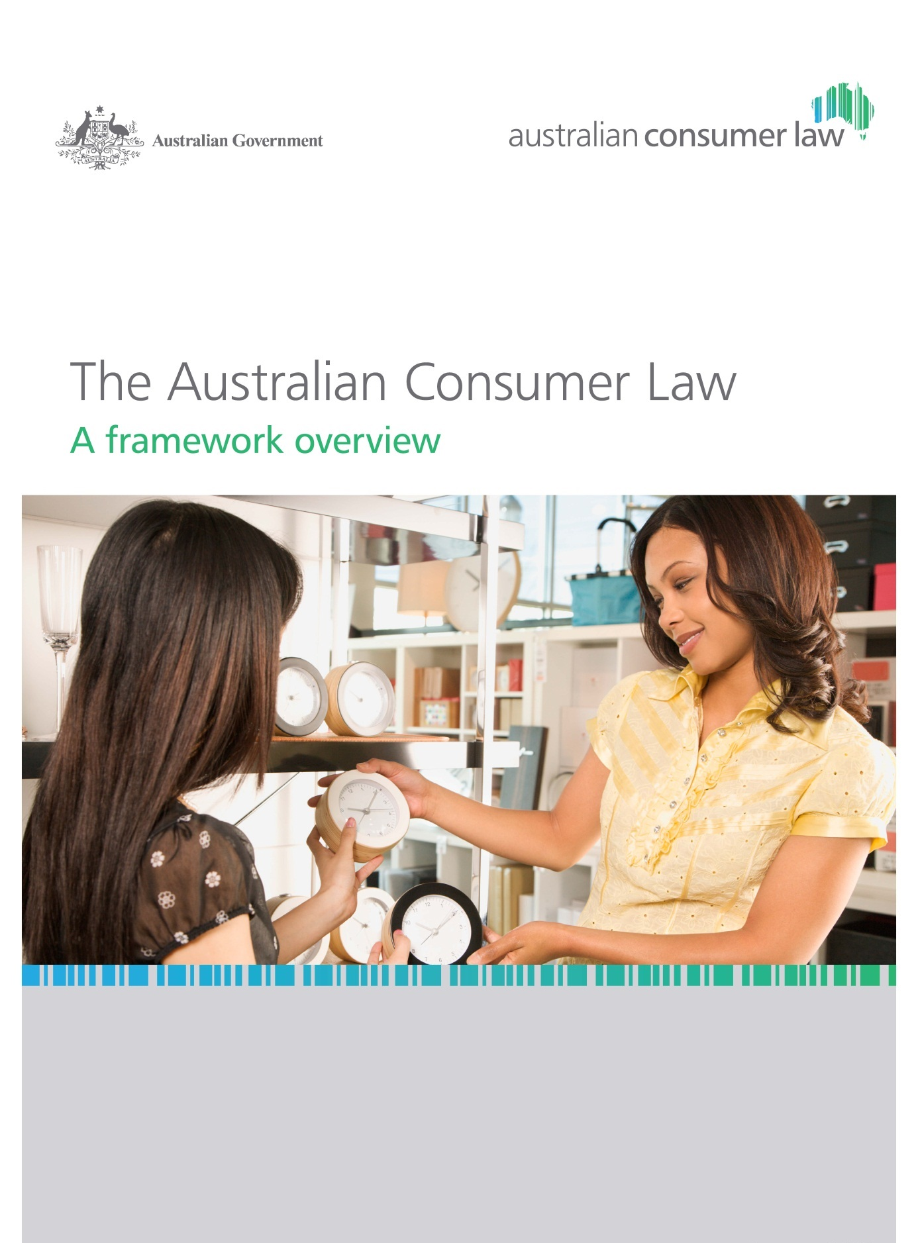

© Commonwealth of Australia 2013

ISBN 978-0-642-74877-5

This publication is available for your use under a [Creative Commons Attribution 3.0 Australia](http://creativecommons.org/licenses/by/3.0/au/deed.en)   
licence, with the exception of the Commonwealth Coat of Arms, the Treasury logo,   
photographs, images, signatures. The full licence terms are available from <http://creativecommons.org/licenses/by/3.0/au/legalcode>.

CC by_grey

Use of Treasury material under a [Creative Commons Attribution 3.0 Australia](http://creativecommons.org/licenses/by/3.0/au/deed.en) licence requires you to attribute the work (but not in any way that suggests that the Treasury endorses you or your use of the work).

*Treasury material used ‘as supplied’.*

Provided you have not modified or transformed Treasury material in any way including, for example, by changing the Treasury text; calculating percentage changes; graphing or charting data; or deriving new statistics from published Treasury statistics — then Treasury prefers the following attribution:

*Source: The Australian Government the Treasury.*

Derivative material

If you have modified or transformed Treasury material, or derived new material from those of the Treasury in any way, then Treasury prefers the following attribution:

*Based on the Australian Government the Treasury data.*

**Use of the Coat of Arms**

The terms under which the Coat of Arms can be used are set out on the It’s an Honour website (see [www.itsanhonour.gov.au](http://www.itsanhonour.gov.au))

**Other Uses**

Inquiries regarding this licence and any other use of this document are welcome at:

Manager

Communications

The Treasury

Langton Crescent Parkes  ACT  2600

Email: [medialiaison@treasury.gov.au](mailto:medialiaison@treasury.gov.au)

# Foreword

The Australian Consumer Law (ACL) is a key part of the deregulatory reforms of the Council of Australian Governments (COAG) to deliver a seamless national economy. The ACL replaced provisions spread across at least 20 Commonwealth, state and territory consumer laws with one law.

The ACL is the culmination of a process of cooperation between the Commonwealth Government and the states and territories through the Ministerial Council on Consumer Affairs (now the Legislative and Governance Forum on Consumer Affairs, or CAF). It draws on the conclusions of the 2008 Productivity Commission (PC) *Review of Australia’s Consumer Policy Framework*,best practice in existing state and territory laws, and consultations undertaken during 2009-10.

Under the *National Partnership Agreement to Deliver a Seamless National Economy*, the Commonwealth, State and Territory governments agreed to complete the legislative process to implement the ACL by 31 December 2010 and that it would commence in all jurisdictions on 1 January 2011.

The ACL was implemented through enactment of the *Trade Practices Amendment (Australian Consumer Law) Act (No. 1) 2010* and the *Trade Practices Amendment (Australian Consumer Law) Act (No 2) 2010*. The full text of the ACL is set out in Schedule 2 to the *Competition and Consumer Act 2010* (CCA).

This overview of the ACL has been prepared as a practical aid to understanding the ACL. Separate guides covering the provisions in the ACL are available for businesses, as well as fact sheets for consumers at [www.consumerlaw.gov.au](http://www.consumerlaw.gov.au/).

Contents

[Foreword iii](#_Toc345678976)

[Glossary of terms vii](#_Toc345678977)

[The role of this guide ix](#_Toc345678978)

[The Australian Consumer Law 1](#_Toc345678979)

[General Protections 2](#_Toc345678980)

[Unfair Practices 2](#_Toc345678981)

[Consumer Transactions 3](#_Toc345678982)

[The Product Safety Law 4](#_Toc345678983)

[Offences 6](#_Toc345678984)

[Enforcement and Remedies 7](#_Toc345678985)

[The development of the ACL 8](#_Toc345678986)

[The drafting of the ACL 9](#_Toc345678987)

[The ACL as an application law 10](#_Toc345678988)

[Supporting the implementation of the acl 12](#_Toc345678989)

[Governance arrangements 12](#_Toc345678990)

[Key ACL resources 14](#_Toc345678991)

[Amending the ACL 15](#_Toc345678992)

[Industry‑specific consumer laws 16](#_Toc345678993)

# Glossary of terms

|  |  |
| --- | --- |
| ACCC | Australian Competition and Consumer Commission |
| ACL | Australian Consumer Law |
| ASIC | Australian Securities and Investments Commission |
| ASIC Act | *Australian Securities and Investments Commission Act 2001* |
| BRCWG | Business Regulation and Competition Working Group |
| CAANZ | Consumer Affairs Australia New Zealand |
| CAF | Legislative and Governance Forum on Consumer Affairs |
| CCA | *Competition and Consumer Act 2010* |
| COAG | Council of Australian Governments |
| IGA | *Intergovernmental Agreement for the Australian Consumer Law,* signed by members of the Council of Australian Governments on 2 July 2009. |
| LG Forum | Legislative and Governance Forum for Corporations |
| PC | Productivity Commission |
| TPA | *Trade Practices Act 1974* |

# The role of this guide

This guide is intended to provide a broad overview of the ACL.

In *The Australian Consumer Law: A guide to provisions* you can find a more detailed explanation of the provisions of the ACL.

For a comprehensive explanation of the ACL, please refer to the text of the ACL, which forms Schedule 2 to the CCA (available at [www.comlaw.gov.au](http://www.comlaw.gov.au/)), or the Explanatory Memorandumsand Supplementary Explanatory Memorandums that are associated with the Acts which implemented the ACL (available at [www.aph.gov.au](file:///\\romulus\csg_h$\MCD\Publishing\Graphic%20Design%20Services%20Team\Projects\2012\Australian%20Consumer%20Law%20Guide%20Covers\supplied\www.aph.gov.au)).

# The Australian Consumer Law

The ACL is a single, national law, which applies in the same way nationally and in each State and Territory. It is the principal consumer protection law in Australia.

Under the ACL, consumers have the same protections and expectations about business conduct wherever they are in Australia. Similarly, businesses have the same obligations and responsibilities wherever they operate in Australia.

The ACL:

* replaced a range of existing Commonwealth, state and territory consumer laws and clarified understanding of the law for Australian consumers and businesses;
* is a schedule to the *Competition and Consumer Act 2010*;
* is applied as a law of the Commonwealth. The ACL is also applied as a law of its jurisdiction in each State and Territory so that the same provisions apply across Australia;
* is enforced by all Australian courts and tribunals, including the courts and tribunals of the States and Territories;
* is administered by the Australian Competition and Consumer Commission (ACCC) and each State and Territory’s consumer law agency; and
* reflects similar protections in the *Australian Securities and Investments Commission Act 2001* (ASIC Act) in respect of financial products and services.

|  |
| --- |
| What does the ACL cover?  The ACL includes:   * core consumer protection provisions prohibiting misleading or deceptive conduct, unconscionable conduct and unfair terms in standard form consumer contracts; * specific protections against certain defined ‘unfair’ practices, including particular instances of misleading or deceptive conduct, pyramid selling, unsolicited supplies of goods and services, component pricing and the provision of bills and receipts; * regulation of certain aspects of consumer transactions, including:   + a system of statutory consumer guarantees for consumer goods and business goods valued below $40,000;   + a national legal framework for unsolicited selling, including door-to-door trading and telephone sales; * a national law for consumer product safety; and * robust enforcement and consumer redress provisions. |

## General Protections

Chapter 2 of the ACL establishes the general standards of business conduct.

### Misleading or deceptive conduct

The ACL prohibits misleading or deceptive conduct in trade or commerce. It is unlawful for a business to make statements in trade or commerce that are misleading or deceptive, or which are likely to mislead or deceive. Failing to disclose relevant information, promises, opinions and predictions can also be misleading or deceptive.

### Unconscionable conduct

The ACL includes provisions prohibiting persons from engaging in unconscionable conduct towards consumers or businesses.

In 2010, the Government amended the ACL to provide that a court may have regard to a number of matters in determining whether there has been unconscionable conduct in relation to the supply or acquisition of goods or services in trade or commerce. These matters include, but are not limited to, the relative strengths of the bargaining positions of the parties, the use of undue influence, pressure or unfair tactics by the stronger party, the willingness of the stronger party to negotiate the terms and conditions of a contract for supply, and the extent to which each party acted in good faith.

### Unfair contract terms

The ACL provides that unfair terms in standard form consumer contracts are void. A consumer contract is one for the supply of goods or services, or for the sale or grant of an interest in land, to an individual for personal, domestic or household use or consumption.

A court may declare a term ‘unfair’ if:

* it would cause a significant imbalance in the parties’ rights and obligations arising under the contract;
* it is not reasonably necessary to protect the legitimate interests of the party that would be advantaged by the term; and
* it would cause detriment to a party if it was relied on.

The unfair contract terms provisions do not apply to business‑to‑business contracts.

## Unfair Practices

Part 1 of Chapter 3 of the ACL sets out specific protections against certain defined business practices. Unlike the general protections in Chapter 2 of the ACL, these provisions are targeted at specific kinds of activities that can be particularly detrimental, such as:

* specific instances of false or misleading conduct in trade or commerce in relation to the supply of goods or services, land transactions or employment;
* failing to supply gifts and prizes, or not supplying them as offered;
* bait advertising;
* wrongly accepting payment for goods and services not supplied;
* pyramid selling schemes;
* certain pricing practices; and
* using harassment and coercion in connection with business activities.

These prohibitions apply generally to all businesses.

## Consumer Transactions

Part 2 of Chapter 3 of the ACL provides certain requirements that businesses must comply with when participating in certain transactions — a system of statutory consumer guarantees and the unsolicited selling law.

### Consumer guarantees

Under the ACL, all goods and services purchased by consumers are covered by statutory consumer guarantees. A business that supplies goods or services must ensure that they comply with all relevant consumer guarantees under the ACL.

|  |
| --- |
| What are consumer guarantees?  When a consumer buys goods or services, the ACL provides that they have guaranteed rights including that:   * the supplier has the right to sell the goods; * the goods are of acceptable quality; * the goods match their description; * the goods are fit for any purpose that the consumer makes known to the supplier; * repairs and spare parts for the goods are reasonably available; * the services are carried out with reasonable care and skill; and * the services are completed within a reasonable time where there is no agreed date. |

Further guidance about the operation of the ACL in respect of consumer guarantees is provided on the ACCC website at [www.accc.gov.au](http://www.accc.gov.au) as well as on State and Territory consumer protection agency websites.

### Unsolicited consumer agreements

The ACL contains a law covering unsolicited sales practices, including door‑to‑door and telephone sales (to the extent not already covered by the *Do Not Call Register Act 2006*).

The unsolicited selling law contains express supplier obligations about the way in which consumers are approached face-to-face, including:

* permitted hours of visiting consumers for the purpose of negotiating an unsolicited consumer agreement, or for a related purpose;
* a duty on the ‘dealer’ to disclose the purpose of their visit and to appropriately identify themselves to the consumer;
* the duty to leave the premises immediately on request; and
* disclosure requirements, including the duty to provide the consumer with a copy of the agreement, and to inform a consumer of their rights to terminate an unsolicited sales agreement within 10 business days of making the agreement and in other circumstances.

### Lay‑by agreements

The ACL includes basic rules that apply to lay‑by agreements, including that the supplier ensure the lay-by agreement is in writing. The ACL also provides that a consumer may terminate a lay-by agreement at any time before the relevant goods are delivered, and that a supplier must not terminate the agreement except in certain circumstances.

### Other provisions

Under the ACL, businesses must provide consumers with a proof of transaction for transactions over $75 and for lesser amounts upon request. If a consumer requests it, a business must also provide an itemised bill for services within seven days of the request.

### Information standards

Information standards can be made by the Commonwealth Minister. Information standards require suppliers to provide certain information to consumers when supplying particular kinds of goods and services.

Liability of manufacturers for goods with safety defects

Under the ACL, manufacturers are liable to compensate affected persons for loss or damage suffered as a result of supplying goods with a safety defect. Enforcement agencies may also bring an action on behalf of an affected person.

## The Product Safety Law

Under the ACL, a rigorous product safety law applies to consumer goods and product‑related services supplied in Australia. The Commonwealth, and state and territory consumer protection agencies take a coordinated approach to the application and enforcement of the product safety law across Australia. The ACL also outlines the responsibilities of suppliers under the national product safety framework.

The ACCC and state and territory consumer protection agencies are responsible for monitoring the market to detect unsafe goods and identify ways to address hazards or encourage safe practices. This can be through consumer awareness campaigns, safety warning notices, product recalls, product bans or mandatory safety standards.

Further information about the product safety framework is available on the Product Safety Australia website: [www.productsafety.gov.au](http://www.productsafety.gov.au). The Product Safety Australia website provides safety information on various consumer goods, which are intended for personal, domestic or household use. It also allows consumers and suppliers to make a mandatory report, report an unsafe product, or make an inquiry.

### Mandatory safety standards

Mandatory safety standards can be declared by the Commonwealth Minister, and are introduced when considered reasonably necessary to prevent or reduce the risk of injury to a person. A mandatory standard can specify various safety requirements such as the way products are made, what they contain, any tests they need to pass, and warnings and instructions that must accompany them.

A business must not supply consumer goods or product‑related services unless they comply with relevant mandatory safety standards in force for those kinds of consumer goods or product‑related services. More information is available at [www.productsafety.gov.au/mandatorystandards](http://www.productsafety.gov.au/mandatorystandards).

### Bans

Bans can be placed on consumer goods or product-related services if there is evidence of a risk of serious injury, illness or death associated with the goods or services. A ban can be interim (temporary) or permanent.

Permanent bans can only be made by the Commonwealth Minister. Interim bans may be made by the Commonwealth Minister or a state or territory Minister.

A business must not supply consumer goods or product‑related services if they are subject to an interim or permanent ban. More information is available at [www.productsafety.gov.au/bans](http://www.productsafety.gov.au/bans).

### Recalls of consumer goods

The product safety law provides a single national approach to issuing and enforcing recalls of consumer goods. If a consumer good is found to be hazardous, or non-compliant with a mandatory standard or ban, it may need to be recalled by the supplier. Recalls can be initiated voluntarily or in response to an order by the Commonwealth or a state or territory minister responsible for consumer affairs.

The purpose of a recall is to prevent injury by removing the source of the hazard and to offer affected consumers a remedy in the form of repair, replacement or refund. A recall remedy will therefore normally be consistent with the consumer guarantees. Suppliers who undertake a voluntary recall must notify the Commonwealth Minister via the Recalls Australia website. Suppliers must also comply with notification requirements where the goods have been exported. More information is available at [www.recalls.gov.au](http://www.recalls.gov.au).

### Safety warning notices

A safety warning notice can be issued to warn the public that a good or service is under investigation or poses a safety risk. Safety warning notices are posted on the ‘News’ section of the Product Safety Australia website.

### Mandatory reporting

Under the ACL, a supplier of consumer goods or product-related services is required to report deaths, serious injuries or illnesses associated with consumer goods. This requirement is known as ‘mandatory reporting’. All participants in the supply chain of a consumer good or a product-related service are required to comply with the reporting requirements.

A supplier is required to submit a report within two days of becoming aware of a reportable incident. Suppliers can do this using the ACCC’s online form on the Product Safety Australia website. More information is available at [www.productsafety.gov.au/mandatoryreporting](file:///C:\Users\XJS\AppData\Local\Microsoft\Windows\Temporary%20Internet%20Files\Content.Outlook\NW2IJY58\www.productsafety.gov.au\mandatoryreporting).

### Global Recalls Portal

In 2012, the *GlobalRecalls* portal was released at [www.globalrecalls.oecd.org](http://globalrecalls.oecd.org). The online portal is hosted by the OECD, and was developed jointly by the European Union and OECD countries, including the US, Australia and Canada. The portal contains regularly updated information on consumer product recalls issued in countries around the world. Consumers can check for safety alerts about the products they intend to buy, including online purchases from abroad, and governments are better positioned to remove unsafe products from the market.

The Australian consumer product safety enforcement framework under the ACL

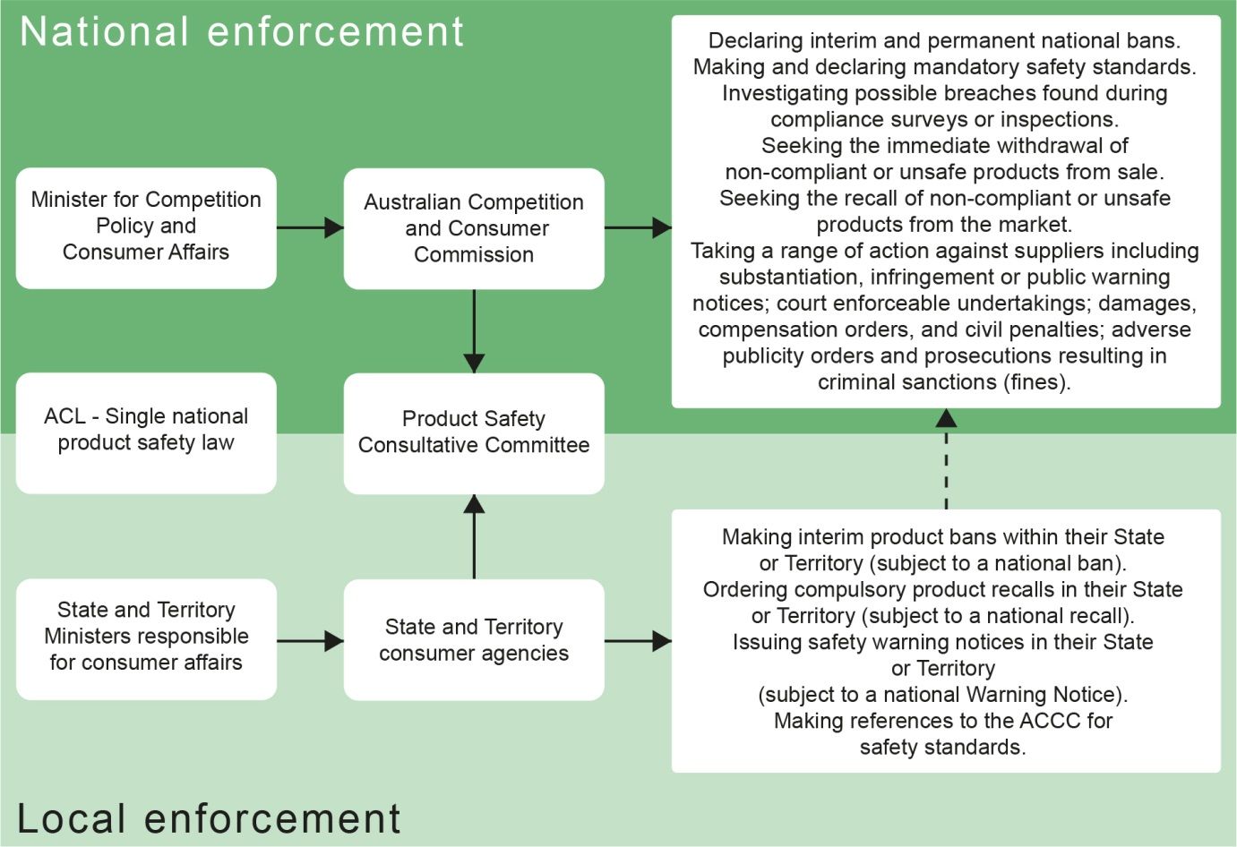

## Offences

Chapter 4 of the ACL creates a criminal offence regime for certain provisions of Chapter 3, and includes rules on:

* defences to offences under the ACL; and
* prosecution timeframes, compensation for those harmed, and penalties for offences of the same nature.

Under the ACL, a corporation convicted of an offence can be liable to having a criminal conviction recorded and paying a fine of up to $1.1 million. An individual can face having a criminal conviction recorded and paying a fine of up to $220,000.

## Enforcement and Remedies

Chapter 5 of the ACL includes enforcement powers, penalties and remedies that can apply for breaches or suspected breaches of the ACL.

### National enforcement powers

* **Enforceable undertakings:** if a person thinks they might have breached the ACL, they can offer a consumer agency an undertaking that they will not do it again and take steps to comply. If accepted by the consumer agency, the undertakings are court‑enforceable.
* **Substantiation notices:** consumer agencies can issue a notice to a business seeking information and documents about claims made in the marketplace to determine if they are genuine and whether further investigation is necessary.
* **Public warning notices:** consumer agencies can issue a public warning notice about businesses where they have reasonable grounds to suspect that a business may have breached the ACL, or has refused or failed to respond to a substantiation notice.

### National consumer law remedies

* **Civil pecuniary penalties:** consumer agencies can seek monetary penalties for contraventions of the ACL. These penalties may be imposed if the contravention is proved to the civil standard—that is, on the balance of probabilities.
* **Disqualification orders**: consumer agencies may apply to a court for an order disqualifying a person from managing a corporation for a contravention of the ACL.
* **Non‑punitive orders:** consumer agencies may apply to a court for a non‑punitive order for a contravention of the ACL. The court may impose a remedy to redress harm suffered in the community from a contravention. Such orders will help those in breach to comply with the ACL in the future.
* **Adverse publicity orders:** consumer agencies may apply to a court for an adverse publicity order in respect of a contravention of the ACL.
* **Declarations:** the ACL provides that a declaration may be made that a term in a standard form consumer contract is unfair.
* **Injunctions:** consumer agencies or an affected person may seek an injunction to stop a business from engaging in conduct in breach of the ACL, or to require the business to do certain things.
* **Damages:** if a contravention of the ACL causes loss or damage to a person, they can apply to recover damages in that amount.
* **Compensatory orders:** people affected by a breach of the ACL can seek compensatory orders for loss or damage suffered or likely to be suffered as a result. Consumer agencies can also seek compensation on behalf of named parties.
* **Redress for non‑parties:** consumer agencies may seek particular remedies such as refunds or contract variations to remedy a breach of the ACL in certain circumstances without first establishing the identity of those persons whom the breach affected.

### Defences

There are certain defences available for breaches of the ACL, including specific defences concerning country‑of‑origin representations.

Figure 1: Enforcement and remedies under the ACL



# The development of the ACL

Australia’s Commonwealth, state and territory consumer protection laws—which apply to all industries and economic activities—have, over time, diverged in their form and scope.

In its 2005 *Review of National Competition Policy Reforms[[1]](#footnote-1)*, the PC identified consumer protection legislation as one of four priority areas for further reform. The PC found that although the benefits and costs of consumer protection legislation are much less tangible, it seemed clear that ineffective national coordination mechanisms have led to regulatory inefficiencies and inconsistencies, to the detriment of both consumers and businesses. The PC recommended that the Australian and State and Territory governments should establish a national review into consumer protection policy and administration.

The January 2006 report of the Taskforce on Reducing Regulatory Burdens on Business[[2]](#footnote-2) reiterated this finding, based on submissions received from a wide range of stakeholders.

In May 2008, the PC recommended the development and implementation of a single national consumer law after an extensive consultation process. Australian and New Zealand Ministers with responsibility for consumer affairs also recommended the implementation of a national consumer product safety system.

The ACL has delivered on these recommendations. In particular, the ACL provides all Australian consumers the same protections wherever they are.

The ACL has simplified the law and made it clearer to understand for both consumers and businesses. More informed consumers make better choices, driving competition and innovation in markets and the development of a seamless national economy. The ACL has also simplified business compliance across Australia, by reducing the number of laws and the number of requirements with which they must comply.

# The drafting of the ACL

The ACL was drafted in accordance with the requirements of plain language drafting.

Previous TPA provisions included in the ACL were, in most cases, modified and reordered to make the law clearer and also to reflect changes in drafting conventions since they were initially inserted into the TPA. With the exception of those areas where there have been policy changes, these drafting changes are not intended to alter the legal effect of these provisions.

|  |
| --- |
| Plain language drafting  For an explanation of plain language drafting, please refer to the Office of Parliamentary Counsel website <http://www.opc.gov.au>. |

# The ACL as an application law

The ACL is an application law, which is applied and enforced as a law of each jurisdiction in Australia.

The Australian Parliament has applied the ACL as a law of the Commonwealth, and it applies to the conduct of corporations and those associated with them.

Each State and Territory parliament has applied the ACL as a law of its own jurisdiction, and it applies to the conduct of corporations and individuals.



|  |
| --- |
| The constitutional bases of regulating for consumer protection in Australia  The states have a general power to make laws in respect of consumer protection matters, as do the territories, within the scope of the territories power in section 122 of the *Australian Constitution*.  Under the *Australian Constitution*, the Commonwealth does not have constitutional power to make consumer protection laws generally but may make laws with respect to the conduct of corporations and with respect to interstate trade.  The Commonwealth may also make consumer protection laws in respect of financial products and services, as a result of the referral of legislative competence from the states under the *Corporations Agreement 2002*. In 2009, the States also referred their specific powers concerning consumer credit. |

|  |
| --- |
| How does the ACL regulate the conduct of ‘persons’ and ‘corporations’?  As an application law, the ACL has been drafted to reflect that it is a law of the Commonwealth and of each State and Territory. Consequently, all of the provisions have been drafted to apply to the conduct of ‘persons’ rather than ‘corporations’.  This drafting has not altered the scope of effect of any law of the Commonwealth or a State or Territory under the *Australian Constitution*.  Part XI of the CCA applies the ACL as a law of the Commonwealth and references to ‘persons’ apply, for the purposes of the ACL, to ‘corporations’ as a law of the Commonwealth. |

|  |
| --- |
| How does the ACL interact with existing State and Territory dispute resolution systems?  The CCA and a State or Territory’s application Act specify that the ACL is a law of the relevant jurisdiction.  The CCA and the State and Territory application Acts:   * govern the way in which consumers can access Commonwealth, state and territory courts and tribunals; * deal with administrative and judicial review procedures in respect of the actions of regulators under the ACL; and * deal with specific enforcement issues and procedures, which reflect different policy approaches to the administration and enforcement of the law around Australia. |

|  |
| --- |
| Does the ACL regulate financial services and consumer credit?  The *Australian Securities and Investments Commission Act 2001* (ASIC Act) applies to financial products and services.  This reflects the current referral of power by states and territories under the *Corporations Agreement 2002*, which is administered by the Legislative and Governance Forum for Corporations (LG Forum). The consumer protection provisions of the ASIC Act have been amended to maintain consistency with the ACL.  The power to regulate consumer credit was referred to the Commonwealth by states and territories in 2009. Consumer credit is regulated under the *National Consumer Credit Protection Act 2009*. |

|  |
| --- |
| Who enforces the ACL?  National, state and territory consumer agencies jointly administer and enforce the ACL. The relevant agencies are:   * the ACCC; * NSW Fair Trading; * Consumer Affairs Victoria; * Queensland Office of Fair Trading; * WA Department of Commerce - Consumer Protection; * SA Consumer and Business Services; * Consumer Affairs and Fair Trading Tasmania; * ACT Office of Regulatory Services; and * NT Consumer Affairs.   ASIC enforces the consumer protection provisions of the ASIC Act and the *National Consumer Credit Protection Act 2009*.  The enforcement activities of these agencies are supported at an operational level by a Memorandum of Understanding. |

# Supporting the implementation of the acl

## Governance arrangements

The ongoing implementation of the ACL is supported by a range of committees and bodies as outlined below and in Figure 2.

In 2011, the Ministerial Council on Consumer Affairs (MCCA) transitioned to the **COAG Legislative and Governance Forum on Consumer Affairs (CAF)**. CAF consists of all Commonwealth, State, Territory and New Zealand Ministers responsible for consumer policy.

**Consumer Affairs Australia and New Zealand** (CAANZ) is a sub-committee of CAF, and is made up of the senior officers from consumer affairs or fair trading jurisdictions in each State and Territory, as well as the Australian Government and New Zealand. CAANZ is supported by three advisory committees and the Product Safety Consultative Committee (PSCC):

* The **Policy and Research Advisory Committee (PRAC)** focuses on the development of common policy approaches to national consumer issues, particularly as they relate to the ACL, and on coordinating the development of any amendments to the ACL. PRAC also conducts national consumer policy research.
* The **Education and Information Advisory Committee (EIAC)** focuses on national cooperation and coordination for education and information activities relating to the ACL and consumer issues more generally.
* The **Compliance and Dispute Resolution Advisory Committee (CDRAC)** focuses on national cooperation and coordination for compliance, dispute resolution and enforcement activities relating to the ACL and consumer issues more generally. CDRAC is supported by a Fair Trading Operations Group (FTOG), which deals with day‑to‑day liaison on enforcement issues.
* The **Product Safety Consultative Committee (PSCC)** provides a forum for regular engagement with the state and territory consumer agencies on product safety policy, enforcement and awareness issues, and engages with the other committees as required.

Figure 2: Governance arrangements

**FTOG**Fair Trading Operations Group

**NICS**National Indigenous Consumer Strategy

**CAANZ  
*Consumer Affairs Australia and New Zealand***  
Australia and New Zealand’s consumer affairs agencies

**CCG**Committee Chairs Group / Chair: CAANZ Chair

**CAF  
*COAG Legislative and Governance Forum on Consumer Affairs***Ministers responsible for consumer affairs

**CDRAC**Compliance & Dispute Resolution Advisory Committee

**PRAC**Policy & Research Advisory Committee

**EIAC**Education & Information Advisory Committee

**PSCC**Product Safety Consultative Committee

## Key ACL resources

Australian consumer agencies have prepared guidance to help businesses and consumers understand the key elements of the ACL. General resources on the ACL are available at [www.consumerlaw.gov.au](http://www.consumerlaw.gov.au), as well as on the ACCC and State and Territory consumer protection agency websites. Resources include:

* ACL fact sheets outlining how the ACL applies to consumers and businesses in different contexts;
* guidance on avoiding unfair business practices;
* a guide on consumer guarantees;
* a guide to the unfair contract terms law;
* a Product Safety guide; and
* a Sales Practices guide covering unsolicited supplies, unsolicited consumer agreements, lay-by agreements etc.

# Amending the ACL

The Australian, state and territory governments agreed to the *Intergovernmental Agreement for the Australian Consumer Law* (the IGA) on 2 July 2009.

The IGA provides for the administration of the IGA over time, and sets out the procedures for the amendment of the ACL.

|  |
| --- |
| What is the procedure for amending the ACL?[[3]](#footnote-3)   * The Commonwealth Government, a State or a Territory may submit a proposal to amend the ACL, and provide this to all other jurisdictions. * The Commonwealth Government will commence a consultation process within four weeks of receiving a proposed amendment, which involves:   + the Commonwealth Minister writing to all States and Territories notifying them of the amendment and providing three months from the date of that notice to consider and respond to the proposal in writing;   + after three months the Commonwealth Minister will call a vote. States and Territories will have 35 days to vote, and if they do not vote or abstain within that period, then they will be taken to have supported the proposed amendment; and   + to be successful, the proposed amendment must be supported by the Commonwealth Government and at least four other jurisdictions, of which three must be States. * The Commonwealth Government may make minor or inconsequential amendments to the ACL, provided it notifies the States and Territories of its intention to do so. It may not proceed with such amendments, if a State or Territory objects within 21 days of their receiving notice. In this situation, the Commonwealth Minister must call a vote. * After an amendment has been agreed by the Commonwealth Government and the States and Territories, the Commonwealth Government will then introduce legislation to amend the ACL into the Australian Parliament.[[4]](#footnote-4) |

# Industry‑specific consumer laws

The ACL is a generic law, designed to apply consistently to conduct across all sectors. The ACL is supported by industry‑specific consumer laws at the Commonwealth and State and Territory level, where appropriate.

The IGA provides that, after enacting the ACL, all jurisdictions will repeal, amend or modify any legislation that is inconsistent with or alters the effect of the ACL. This will be done as part of an ongoing process by jurisdiction when reviewing existing legislation and introducing new legislation.

1. Recommendation 10.2, Productivity Commission 2005, *Review of National Competition Policy Reforms*, Inquiry Report No. 33, Canberra. [↑](#footnote-ref-1)
2. Recommendation 4.44, Regulation Taskforce 2006, *Rethinking Regulation: Report of the Taskforce on Reducing Regulatory Burdens on Business*, Report to the Prime Minister and the Treasurer, Canberra. [↑](#footnote-ref-2)
3. See clauses 8-19 of the IGA. [↑](#footnote-ref-3)
4. Amendments to the ACL are required to be separately enacted in Western Australia. [↑](#footnote-ref-4)